Git Assignment 1

* Install GIT & make sure it is added into PATH.
* Use GIT as local VCS. Steps to follow:

1. Create a directory ‘project_dir’ & cd to ‘project_dir’.

C:\Users\HFT0002\Desktop\asgnmnt\1.PNG

1. Initialize git version database. (git init)

C:\Users\HFT0002\Desktop\asgnmnt\2.PNG

1. Create a new file index.html.

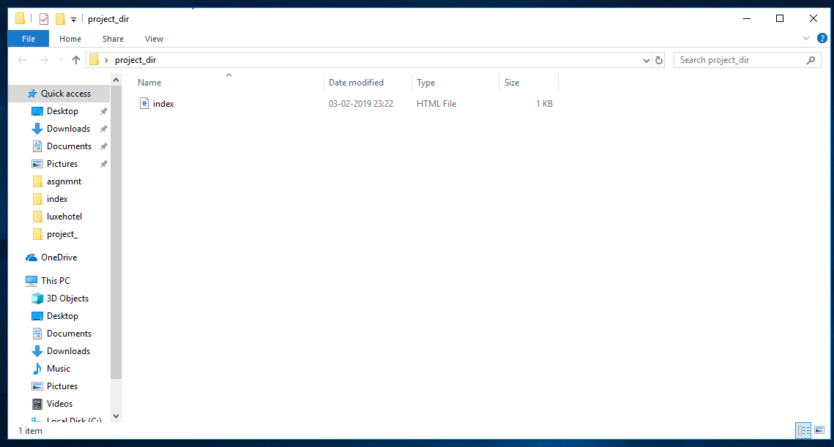

1. Check the git status. You should find index.html as untracked file.

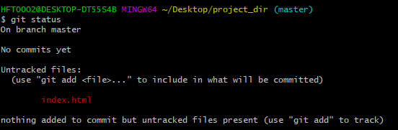

1. Stage the index.html file.

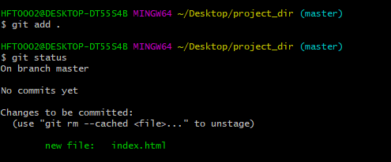

1. Commit index.html

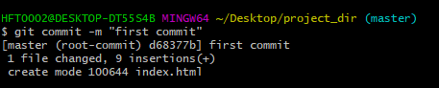

1. Make few changes in index.html & create a new file info.txt file.

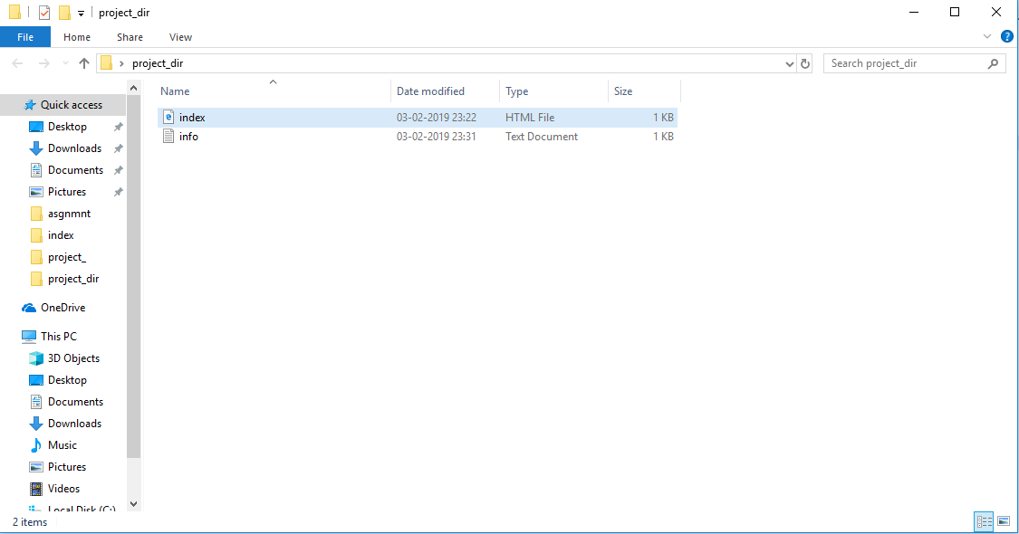

1. Check git status. You should find index.html & info.txt as untracked files.

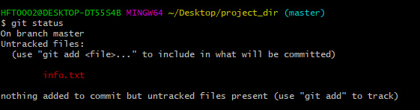

1. Configure GIT to ignore all txt files.

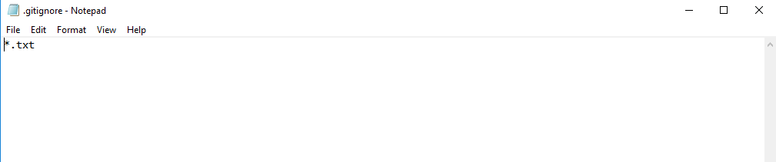

1. Again check the git status. You should find only index.html as untracked file.

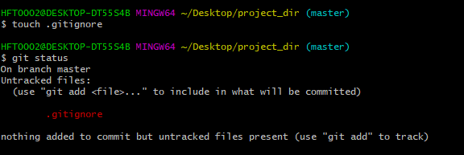

1. State & commit index.html

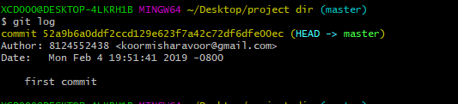

1. Log all your comments so far



1. Make some changes in index.html.

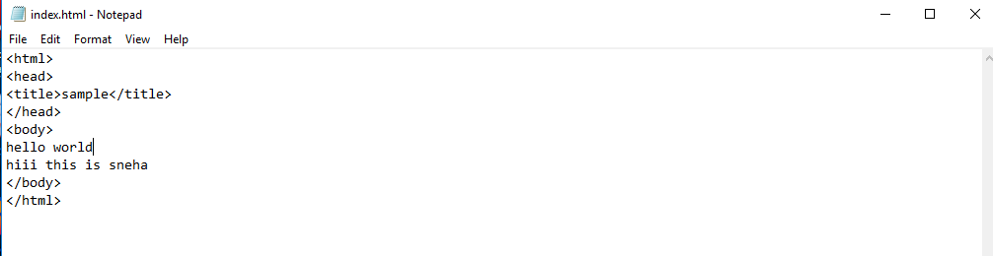

1. Revert the change made in the previous step using git command.

C:\Users\HFT0002\Desktop\asgnmnt\14.1.PNG

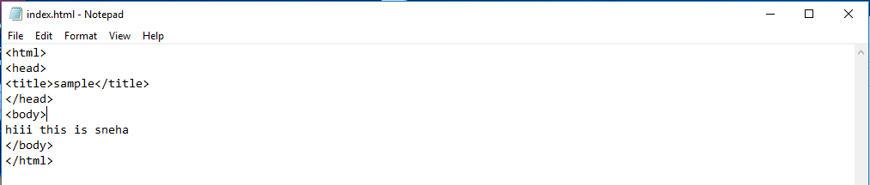

1. Again change index.html



1. Stage index.html

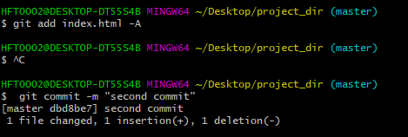

1. Revert back the last stage.

C:\Users\HFT0002\Desktop\asgnmnt\17.1.PNG



1. Rename ‘add’ command to ‘my-add’.

C:\Users\HFT0002\Desktop\asgnmnt\18.1.PNG

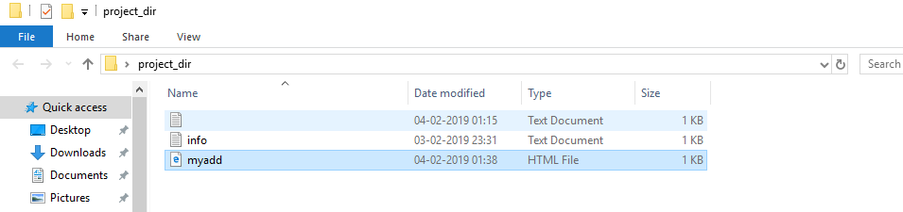

1. Using my_add command Stage index.html again & commit the changes.

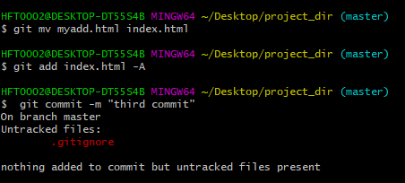

1. Revert the last commit.

C:\Users\HFT0002\Desktop\asgnmnt\20.PNG